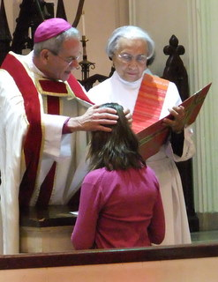
The Laying On of Hands – In the Rite of Confirmation
The laying of hands on the candidates by the bishop and the concelebrating priests represents the biblical gesture by which the gift of the Holy Spirit is invoked.
The concelebrating priests stand near the bishop. He faces the people and with hands joined, sings or says:
Bishop: My dear friends, in baptism God our Father gave the new birth of eternal life
to his chosen sons and daughters. Let us pray to our Father that he will pour out the Holy Spirit to strengthen his sons and daughters with his gifts and anoint them to be more like Christ the Son of God.
All pray in silence for a short time.
The bishop and the priests who will administer the sacrament with him lay hands upon all the candidates (by extending their hands over them).
The bishop alone sings or says:
All-powerful God, Father of our Lord Jesus Christ, by water and the Holy Spirit you freed your sons and daughters from sin and gave them new life.
Send your Holy Spirit upon them to be their Helper and Guide. Give them the spirit of wisdom and understanding, the spirit of right judgment and courage,
the spirit of knowledge and reverence. Fill them with the spirit of wonder and awe in your presence.
We ask this through Christ our Lord.
All: Amen.
Reference
RCL Benziger. (2011). Walkthrough of the Confirmation Rite. Retrieved from http://rclbsacraments.com/confirmation/walkthrough-confirmation-rite

