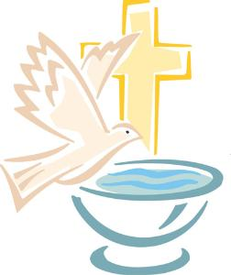
Renewal of Baptismal Promises – In the Rite of Confirmation
After the homily the candidates stand and the bishop questions them:
Bishop: Do you reject Satan and all his works and all his empty promises?
Candidates: I do.
Bishop: Do you believe in God the Father almighty, creator of heaven and earth?
Candidates: I do.
Bishop: Do you believe in Jesus Christ, his only Son, our Lord, who was born of the Virgin Mary, was crucified, died, and was buried, rose from the dead, and is now seated at the right hand of the Father?
Candidates: I do.
Bishop: Do you believe in the Holy Spirit, the Lord, the giver of life, who came upon the apostles at Pentecost and today is given to you sacramentally in confirmation?
Candidates: I do.
Bishop: Do you believe in the holy catholic Church, the communion of saints,
the forgiveness of sins, the resurrection of the body, and life everlasting?
Candidates: I do.
Bishop: This is our faith. This is the faith of the Church. We are proud to profess it
in Christ Jesus our Lord.
All present: Amen.

Reference
RCL Benziger. (2011). Walkthrough of the Confirmation Rite. Retrieved from http://rclbsacraments.com/confirmation/walkthrough-confirmation-rite

